**Lambda Expressions Introduction**\* Lambda Expressions, often called Lambdas, are a new feature introduced with Java 8.  
* What they do is they provide us with an easier way to work with interfaces that have only got   
1 method.  
* They are often used in places where we use anonymous classes.  
* **Let’s use a Runnable object to create and run a Thread**:  
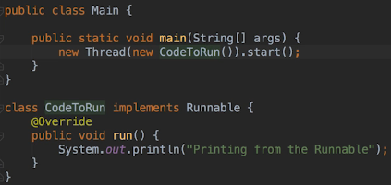  
* This works and it’s one way of doing it.  
* **We could also use an anonymous class**:  
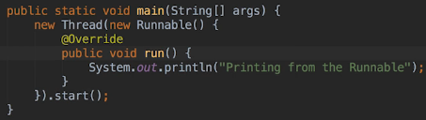  
* In both cases we had to write several lines of code to accomplish what we wanted to do when all we really care about is the println statement, everything else was sort of a filler code to be able to execute it.  
* Would be nice if we could just pass the println statement to the Thread constructor and not have to write all the extra code that isn’t really doing anything.  
* Using a **Lambda** **Expression** we can do that.  
  
*  **() -> code ;**  
* Every lambda expression has 3 parts:  
1) **argument list**  
2) **arrow token ->**  
3) **body**  
* When the compiler sees a lambda expression, how does it know what to do?  
=> Well it knows that one of the Thread classes constructors accepts a Runnable parameter and in addition it also knows that the Runnable interface only has one method - in this case run() - which doesn’t take any parameters so it’s able to match the lambda expression’s argument list with the run() method.  
* Because the compiler needs to match the lambda expression to a method, lambda expressions can only be used with **interfaces that contain only one method that has to be implemented**.  
* These interfaces are also referred to as **functional interfaces**.  
* By using a lambda expression instead of creating a class that implements Runnable or using an anonymous class, we’re actually able to reduce the lines of code we have to write and we can focus on the code we want to run.

* **You can’t use ; when it only has 1 statement**.

* Notice that IntelliJ recognizes lambdas and marks them with the lambda symbol in the editor’s gutter:  
  
* If you click that symbol, it takes you to the method that IntelliJ believed the lambda expression mapped to.  
* **If we want to do more in the lambda, all we have to do is surround the lambda’s body with {}.**  
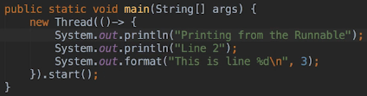  
* Let’s create an Employee class.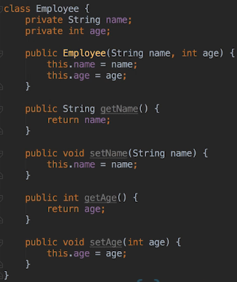  
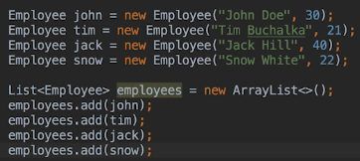  
* Let’s sort the Employeed by name in ascending order and print results.  
* First let’s look at code that doesn’t use a lambda expression:  
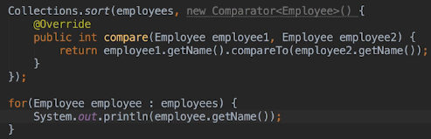  
* Let’s have a look at the documentation for the Comparator<T> interface.  
=> It contains 2 methods that don’t have default implementations: compare() and equals() so compare:

  
  
* We said that we can only use the lambdas for interfaces that require the implementation of only   
1 method but the comparator() documentation states at the top that the comparator() implementation is a functional interface.  
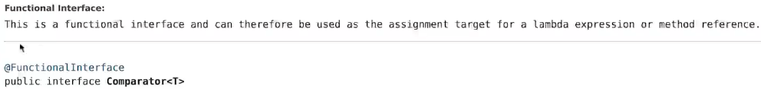  
* In our example inside the Collections.sort() we implemented the compare() method which uses the String compareTo() method to compare the names. The return value of compareTo() matches what the compare() method also wants to return - a negative number when the first value is less than the second value. A positive integer when the first value is greater than the second value. And 0 when the 2 values are equal. So in this case it’s ok to return the compareTo() result as the result of our compare() method.  
* **Now let’s change the code to use a lambda expression**.  
* We can use a lambda even though there are 2 methods that we can implement because the equals() method will always have a default implementation.  
* **Now remember that all classes descend from Object and Object contains an equal() method and that means that every instance that implements Comparator<T> will already have an implementation of the equals() method, therefore the Comparator interface really only has 1 method that always has to be implemented by classes that implement it**.  
=> **For that reason it’s a functional interface and we can use lambdas instead of an anonymous class**.  
* Tricky, yes, and you don’t have to know or memorize the stuff - an interface’s documentation will sometimes tell you if it’s a functional interface and if it doesn’t, the IDE you’re using might.  
* **We can see the the `new Comparator<Employee>()` is grayed out in the editor and if we hover over this, we see that IntelliJ will pop up a message and says that we can actually replace the anonymous class with a lambda**.  
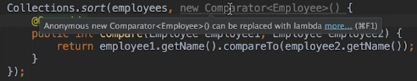  
* So it’s good to know in theory but in practice if you want to know if you can use a lambda expression, check the interface’s documentation or just try it.

**Lambda Expressions Continued**  
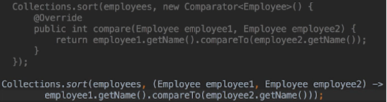  
* When the sort() method needs to compare() 2 objects in the list, instead of calling the compare() method of our Comparator and passing it in the 2 objects, it will instead evaluate the Lambda Expression using the 2 objects it wants to compare as the parameters to the Lambda.

* One nice thing about lambdas is that it’s easy to see what code will be run. And this is especially true when dealing with shorter methods. When one or two lines of code are buried within an anonymous class, that can actually be hard to spot very quickly.  
* The good news is we can actually simplify this lambda expression even further.  
**=> The compiler can infer the parameter types and we don’t actually need to include the types in the lambda. In our case the compiler can infer from the first parameter `employees` that the objects to be compared will both be of type Employee**.  
  
* **If there’s only 1 parameter, we don’t need the parentheses in the argument list**.  
* Let’s look at a common use of lambdas, we’ll use a JavaFX application.  
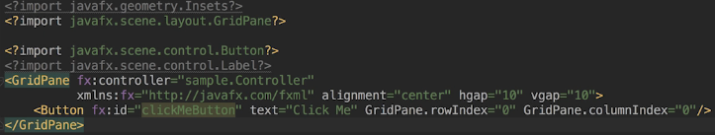  
* We’ve seen how to add action handlers but let’s suppose we want to do it in the fxml file.  
* Using anonymous classes to create even handlers is very common in UI programming, especially in Java’s old tool kit Swing which didn’t have anything like fxml, everything had to be done using code.  
* Whenever we see an anonymous class definition that only overrides 1 method, we can use lambda.  
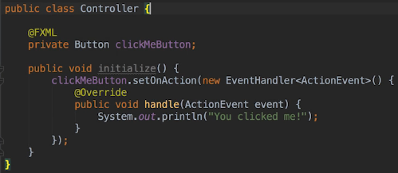  
* Using lambda:  
  
* What about interfaces with a single method that returns a value?  
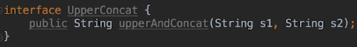  
  
=> The method accepts an object that implements UpperConcat.  
* In the main() method:

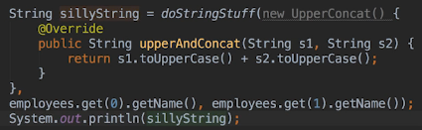  
* We still have to define the interface, we can’t get away from doing that when using lambdas but we can definitely simplify the rest of the code by passing a lambda instead of an anonymous class.  
  
* Notice we haven’t included the return keyword. We can’t actually do it.  
=> When the lambda body consists of a single statement that evaluates to a value, return keyword is assumed and the return value is inferred to be the type of the evaluated value which in this case is String.  
* We can go 1 step further, the compiler can infer the types of the parameters.  
  
* Now that we have a lambda, we can use it as the 1st parameter in our call to doStringStuff().  


**Lambda Expressions Nested Blocks**  
* This is how to do more things in a lambda:  
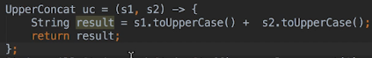  
* We could have done it in only 1 line of code if we passed the lambda expression directly to doStringStuff() rather than saving it to a variable first but I just wanted to show you that **we can assign lambdas to variables and use them later**.  
* Now let’s create a class that isn’t static so that we can take a look at lambda expressions and scope.  
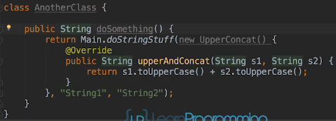  
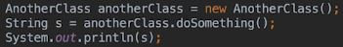  
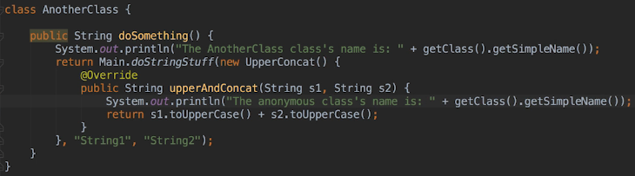  
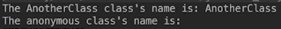  
* **The anonymous class’s name is nothing and that’s correct**.  
* Let’s now try it with a lambda:  
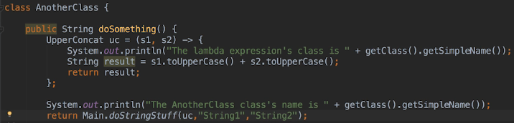  
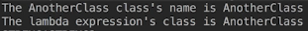  
=> **It’s telling us that a lambda expression isn’t a class**.  
* **When the code runs, an anonymous instance isn’t created. Instead, the lambda is treated like a nested block of code and it has the same scope as a nested block**.  
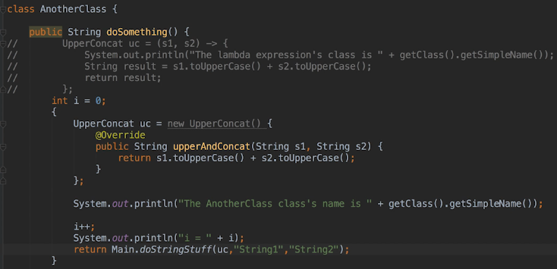  
=> **The code within the nested block can use the local variable i because nested blocks are in the enclosing block scope**.  
* But what about the anonymos class though?  
=> If we want to reference a local variable defined outside the anonymous class, we have to declare the local variable as final.   
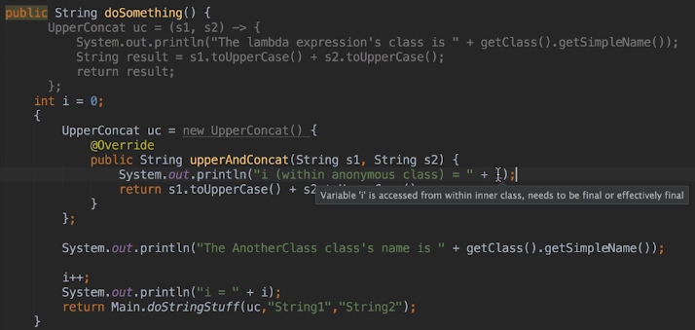  
* It complains that it’s not final so let’s add final:  


* **The question is: why do local variables have to be declared as final when we uise them within an anonymous class?**  
=> That’s because the local variable doesn’t belong to the anonymous class instance.  
=> What actually happens under the covers is that the variable is replaced by whatever the value of i is when the instance is constructed.   
* So it’s possible we may not use the instance of an anonymous class for a while, we may even pass it to a method in another class and **there’d be no way for the Java Runtime to update the value within an anonymous class instance every time it changed within the doSomething() method - in other words the values would get out of sync**.  
**=> For that reason, values of local variables declared outside the scope of the anonymous class are not allowed to change, they have to be declared as final**.  
* In the next video, let’s see how Lambda Expressions are treated like nested blocks.

**Scope and Functional Programming**  
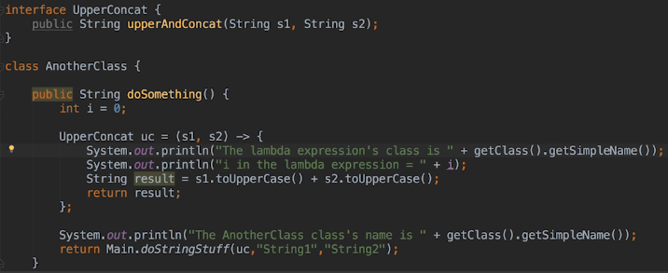  
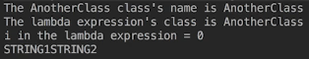  
* Let’s change the i value to see what happens:  
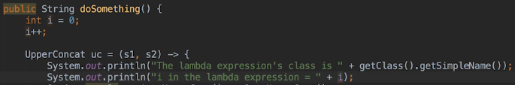  
  
* IntelliJ complains. Any local variable we wanna use from the enclosing block has to be effectively final for the same reason that local variables have to be declared final if we wanna use them within an anonymous class’ code.  
**=> That means that the variable has to be either declared final or it’s value must never change.**\* What about the variables we define inside the lambda? The parameters work the same way, but they’re not local variables.  
**=> Can’t use them outside the enclosing block.**\* When working with lambdas, if we want to use the local variables declared in the lambda’s enclosing block, they have to be effectively final so that the Runtime will know what values to use when the lambda expression is evaluated.

* When the code runs, the Thread will sleep for 5 seconds and then print the value of the number variable. When the Thread is sleeping, the printValue() method will continue to execute and will exit and that means that by the time the Thread gets around to printing the number, the local variable will no longer exist.  
=> Since any variables in the lambdas are set when the lambda is processed by the Runtime and the values of those variables won’t change because they’re effectively final, the Runtime knows it can use the value of 25. That’s because that was the value of number when it processed the lambda. So in larger applications quite a bit of time may elaps between creating a Runnable and actually using it.  
=> Because lambdas may not be immediatelly evaluated, any variables that we use within them from outside the lambda, must be final.  
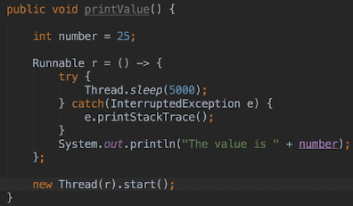  
=> We can change variables declared inside the lambda because those variables are within the lambda’s scope and so can’t be changed outside the lambda. Also they won’t go away because the execution of the enclosing scope has completed - and as in our case of our printValue() method where the method will finish executing before the lambda runs.  
* Let’s try to add a lambda expression to the enhanced for loop. For every employee, we’re gonna start a Thread that prints our their age.  
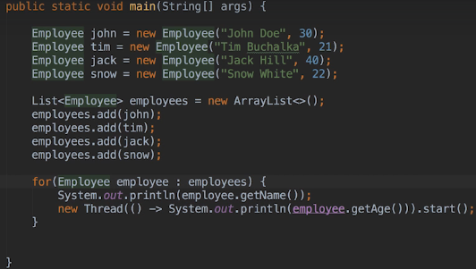  
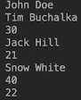 we do get different ordering each time.  
* You might think the employee variable is declared outside the lambda and its value does change.  
=> **In this case the employee variable is effectively final. When using an enhanced for loop, a new local variable is created for each iteration of the loop and that means that the variable is effectively final for each iteration**.

* Let’s use the old style loop:  
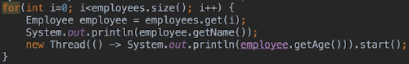  
* That works as well.  
* **Doing this won’t work**:  
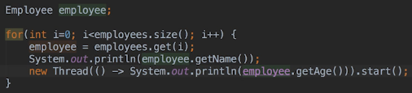  
* When Lambda Expressions were introduced in Java 8, a bunch of other features were also introduced that made use of the lambdas.  
* We’re gonna take a closer look at these features in the upcoming videos.  
* Now let’s look at a new method in the Iterable interface.  
* When we’re iterating over a Collection as we are here, we can use a lambda expression and then a new Iterable forEach() method.  
* The **forEach()** method takes a lambda expression and evaluates it for each item in the Iterable Collection.  
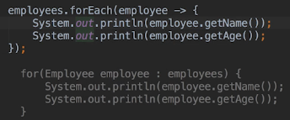  
* There’s a lot going on under the covers when this statement is executed, we’ll take a closer look at what is going on in the next video on the java.util.function package which was introduced in Java 8. That package contains a bunch of functional interfaces meant to be used with Lambda Expressions.  
* How have the lambdas enhanced Java?  
=> Some developers see lambdas as nothing more than a syntactic sugar. A more convenient and concise way of writing anonymous classes. After all they don’t actually add anything to the language that wasn’t already there. We can assign them to variables and pass them around but we can do that with anonymous class objects as well.   
=> Other people say that lambdas are Java’s first step into functional programming which is a programming paradigm that focuses on computing and returning results. There’s a good wikipedia article for more information about functional programming.  
* At the end of the day though, you really have to make your own mind up about how significat you think Lambda Expressions really are.  
* It is important to note that we never have to use a lambda expression and in place for a lambda expression we can always use an anonymous class and some developers prefer to do so.  
* Some lambda expressions can be difficult to read and understand, especially when you didn’t write them yourself.  
* Even if you don’t intend to use them, it is important to know about them and how they work because you might have to work on someone else’s code at some point and they may have used lambda expressions.  
* And also it is possible that future enhancements to Java might bring features that require the use of lambda expressions. But right now it’s up to each developer or employer’s coding standard.

**Functional Interfaces & Predicates**  
* The java.util.function package contains functional interfaces that are meant to be used with Lambda Expressions.  
* The interfaces aren’t meant to do anything specific, they represent the structure of lambda expressions that are commonly used in Java.  
* Let’s reuse our Employee class and also our Main class.  
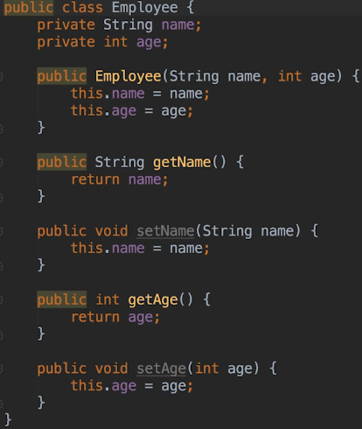 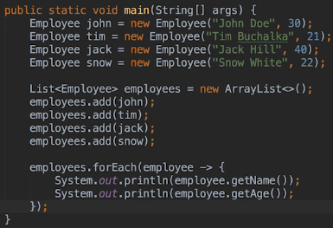  
* If you press CTRL + Q on the forEach, we get the documentation.  
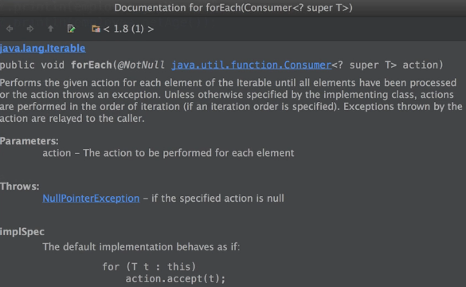  
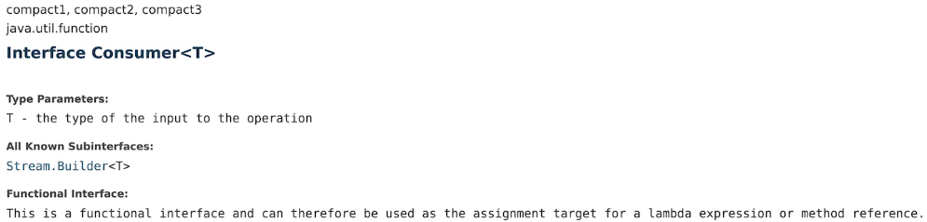  
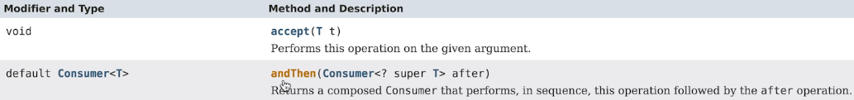  
* Consumer has 1 method that needs to be implemented and so it’s a functional interface and lambdas can therefore map to it.

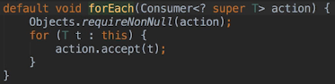  
=> **We pass forEach() a lambda expression that meets the requirements of the Consumer interface**.  
=> The consumer accepts 1 argument and performs an action that doesn’t return a value.  
* It’s called a consumer because it’s `**object in, nothing out**`.  
* This is perfect for when we want to do something like iterate a list and print the contents.  
* Sure we could write an old-style or an enhanced for loop to do the work but doing it on one line of code is concise and clear.  
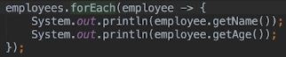  
* The lambda we’re using takes an Employee object and it doesn’t return anything so it matches what the forEach() method expects - a Consumer.  
* When we call forEach(), it iterates over the list. On each iteartion it calls the Consumer’s accept() method, passing the Employee object as the parameter.  
* The accept() method evaluates the lambda expression using the passed Employee object as the argument. It prints stuff and nothing is returned. The Employee is consumed and the iterator moves to the next Employee in the list.  
* As I said, there’s quite a bit going on under the covers when we use forEach() but essentially it boils down to the iterator calling the Consumer’s accept() method for each object in the list. The accept() method evaluates the lambda expression passed to by the forEach() method, using the passed object as the argument. Ultimately it’s the Consumer, which was passed as a lambda expression, that does the work.  
* Let’s say we wanna print out all the employees older than 30.  
> Enhanced for loop:  
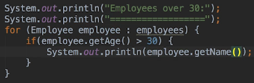  
> Lambda expression:  
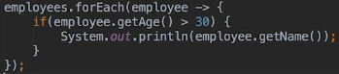  
* Let’s say we wanna print out all the employees <= 30.  
* We would be repeating ourselves, the only difference would be the IF condition. We could move the code into a method and pass a boolean parameter that tells the method whether we want the younger or older. It would work but it feels like a hack. Perhaps there is a better way.  
* **Predicate** Interface java.util.function package.  
* **Predicate** **test()** => the functional method, it accepts a Predicate that returns a boolean value. We can replace the IF conditions we’re using with a Predicate.  
* forEach() expects a Consumer, not a Predicate, so we have to go back to using the Enhanced for loop.

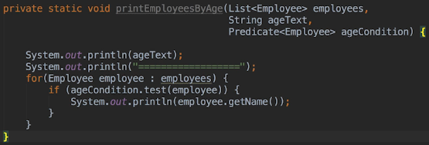  
* The for loop passes each Employee to the Predicate test() method which in turn uses the Employee as the parameter for the lambda expression that maps to the Predicate.  
* It’s the same way the forEach() uses the Consumer.  
* The Predicate arguments are just lambda expressions that match the Predicate interface.  
  
* **This way we can just pass a specific condition to the method instead of writing multiple methods doing essentially the same except for the condition**.

**More on Predicates & Suppliers**  
* We can pass an anonymous Predicate to the method, as we learned before we don’t have to use lambdas.  
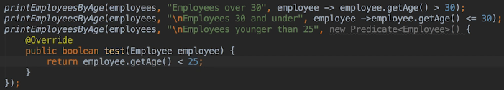  
* So yes we can use an anonymous class here but when working with interfaces in the java.util.function package, it is more common and I thikn personally more convenient to use lambdas.  
* **The Consumer and Predicate interfaces are general interfaces that don’t care about the type of parameter being passed to the lambda expression**. **They’re using GENERICS to infer the type**.  
* There are other Consumer and Predicate interfaces that expect a specific type of parameter, for example the **DoubleConsumer** expects a lambda expression that has a double argument. There’s also an **IntConsumer** and a **LongConsumer**. Also a **DoublePredicate**, **IntPredicate** and **LongPredicate**.  
* Where possible you probably should use the more specific type of lambda to improve readability.  
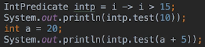 false true  
* So we can reuse Predicates.  
* We can also chain Predicates together.  
* **Predicate**   
**and()  
or()  
negate()  
isEquals()**  
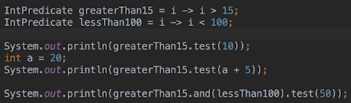

* The more specific Predicate interfaces contain and() or() negate() but they don’t contain isEquals() and they don’t extend Predicate.  
* This chaining is useful if there’s a situation where we need to build a condition on the fly or when we want to reuse some Predicates in different areas of the application.  
* **Supplier** interface => **doesn’t accept any arguments and it does return a value**.  
* Because the Supplier always returns a value, we have to include the expected return type when we declare it.  
* **get()** => to get an object from the Supplier.  
> for loop:  
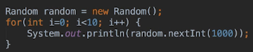  
> Supplier:  
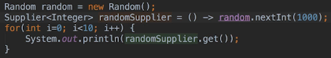  
* Notice the empty argument list in the lambda.  
=> **Just as with other lambda expressions, we can pass Suppliers to methods**.  
* So you could have a situation where sometimes you want to supply an object of type `a` and other times an object of type `b` where `b` is a subclass of `a`.  
* Or perhaps we may have a case where a supplier is providing an IO Stream was used as a counter.  
=> **So we can also use suppliers when testing an application. A supplier could instantiate objects and perhaps populate them with random values**.  
* So just as with Predicates, there’s more specific flavors of Suppliers - boolean, double, int, long.  
* In the next video, we’re gonna start looking at a Function Lambda which uses the Function interface to call lambdas in a different way.

**Functions**  
* Let’s say we want to print out the last names of our employees.  
* **substring()**  
* **indexOf()**  
* Let’s pretend there are multiple places where we need to get the last name of an employee.  
* None of the interfaces we looked at so far matches what we want to do:  
=> **Consumer doesn’t return a value**  
=> **Predicate only returns true or false**  
=> **Supplier doesn’t accept any parameters**  
* **Function** interface => **represents a function that takes 1 parameter and returns a value**.  
> forEach()  
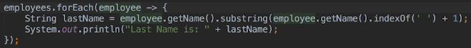  
>  
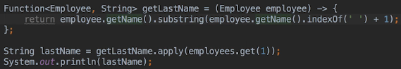  
* We have to use the {} whenever we return a value, even if it’s only 1 line.

* **We could’ve just created a regular old method called getLastName(), also as with other lambda expressions, we could also use an anonymous class**.  
=> **But by using Function we can pass code that accepts and returns a value to a method in the form of a lambda expression and then run the code without having to create an interface and a class that implements the interface**.  
* As we’ve seen previously, we can change what a method does based on the Function we pass in.  
* Let’s suppose that sometime we wanna sometimes get the first name, sometimes the last name.  
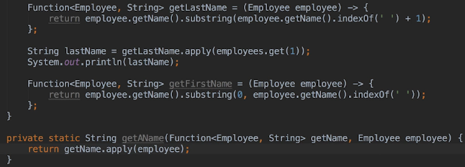  
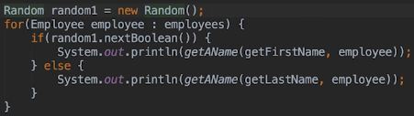  
* **In a more complex application, there may well be cases where we want to run similar code for a set of situations**.  
* **We may have 30 lines of code we want to run and only 2 lines of code will vary depending on the situation. Rather than using interfaces with methods that are called at the appropriate points or writing different methods for every situation, we can pass in functions for the parts that vary. That way the code will be more concise and easy to follow**.  
* Another situation in which Functions are useful is when we want to use **callbacks**. Let’s say we’re **fetching data in a background Thread and when the data is ready**, we want to message it in some way on the background Thread and **the specifics of what we want to do can vary** so we want to be able to specify what code to run when the data has been fetched.  
=> **There are a number of ways to do this - Java provides ways to notify Threads and run code when a background task is completed but we can also use Functions**.  
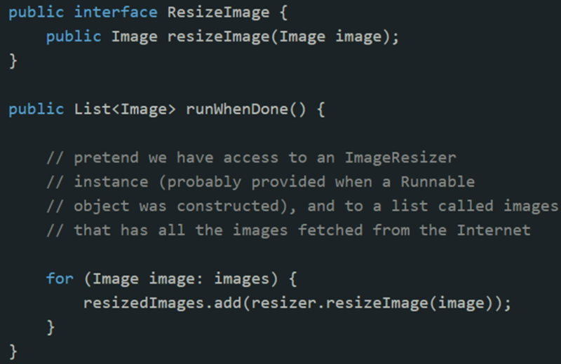  
* We might have to create a ResizeImage implementation for every algorithm.   
=> Or we could use Functions and do the following:  
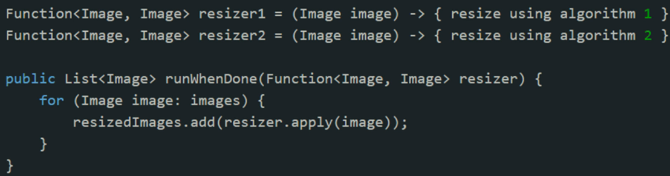  
* This way there’s no need to write an interface and a bunch of classes that then implement that interface. We can create a function for each algorithm we may want to use.  
* Once again using lambdas reduced the amount of code we need to write and in this particular case would make teh code easier to follow.  
=> **Rather than having a bunch of classes each with a resizeImage() method we can define all the Functions in one place**.   
* Anytime we need to use a callback is one option to consider.  
* **Imagine that you want to transform an object in some way and the transformation requires 4 steps. For each step there are several different algorithms you may want to run and which one to run will depend on the state of the applicaiton at the time or on the object that will be transformed**.  
* You could end up having let’s say 90 variations. How would we do this using interfaces in a way that wouldn’t be unwieldy and require us to write lots of implementing classes. Using Functions instead would result in less code and the code would also be easier to read. All we’d really have to do is write a method that accepts 4 Functions and then write the let’s say 13 Functions we may need to use. When we want to transform an object, we pass the appropriate Function for each step.  
* This is really the power and convenience of using lambda expressions.

**Chaining java.util.function Functions**  
* There are also specific types such as: LongToIntFunction accepts a long argument and returns an int value.  
* We can also chain Functions together just as we could with Predicates.  
* **andThen()** => method in the Function interface, takes a Function as a parameter.  
* The function that calls the andThen() will run first and then the function passed as the argument to andThen() will operate on its result.  
* Chaining Functions together requires 2 steps:  
1) Create a **Composed Function** that.  
2) As with any Function we call the apply() method to run the Composed Function.  
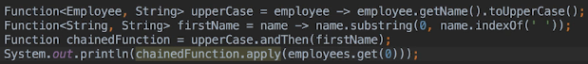  
* The Function interface also contains a **compose()** method that works in the opposite direction to the andThen() method. The Function that calls the compose() method is run second. The Function passed as the argument runs first.  
* Let’s now suppose that we want to concatenate the employee’s name and age and print the result. We’ll need t he employee object in the 2nd step so that we can get the age but we also need the uppercase name from the 1st step. So we actually need 2 arguments but Function only accepts 1.  
=> This is where the **BiFunction** interface comes in. For all the interfaces we’ve discussed accept Supplier there are versions of the interfaces that accept 2 arguments. So in this case we can use the BiFunction interface.  
  
* Can we chain this function to the uppercase function? No we can’t, when we chain functions, the result of one function becomes the argument for the next function but a BiFunction has 2 arguments so it can’t be the 2nd or subsequent function in the chain.  
* However, if the BiFunction was the first step, then we could do it using BiFunction with andThen() method. The BiFunction doesn’t have the compose() method for the same reason that it has to be the first one in the chain.  
* So instead of chaining, we have to uppercase and concatenate the age in 2 steps.  
  
* There are also Consumer and Predicate interfaces that accept 2 arguments but none for Supplier because the Supplier doesn’t accept any arguments.  
* Let’s look at the **UnaryOperator** interface.  
=> This is a more specific type of function that accepts 1 argument and returns a value of the same type as the argument.  
* All the UnaryOperator variants extend the Function interface so therefore they can be chained together just like functions can.  
* **applyAsInt()**  
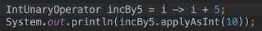  
* We’ve now been through the 5 groups of interfaces in the java.util.function package.  
* At the beginning of this walkthrough of the java.util.function package I said that the interfaces in this package don’t have any meaning in and of themselves. So hopefully at this point you now got a better idea of what that means. The interfaces represent structures for lambda expressions.   
* When we want to use a lambda expression that tests a value and retruns true/false, we can use a Predicate.   
* When we want to use a lambda expression in place for method that accepts an argument and returns a value, we can use Function.   
* The interfaces don’t dictate what the lambdas must do.   
* They’re not like interfaces such as Runnable which we know represents an object with a block of execution code or an EventHandler which we know contains code that will run when the user interacts with the user interface component.  
* The java.util.function interfaces describe the arguments and the return value but not actually what the implementations must do.  
* **Summary of the 5 groups of interfaces in the java.util.function package**.  
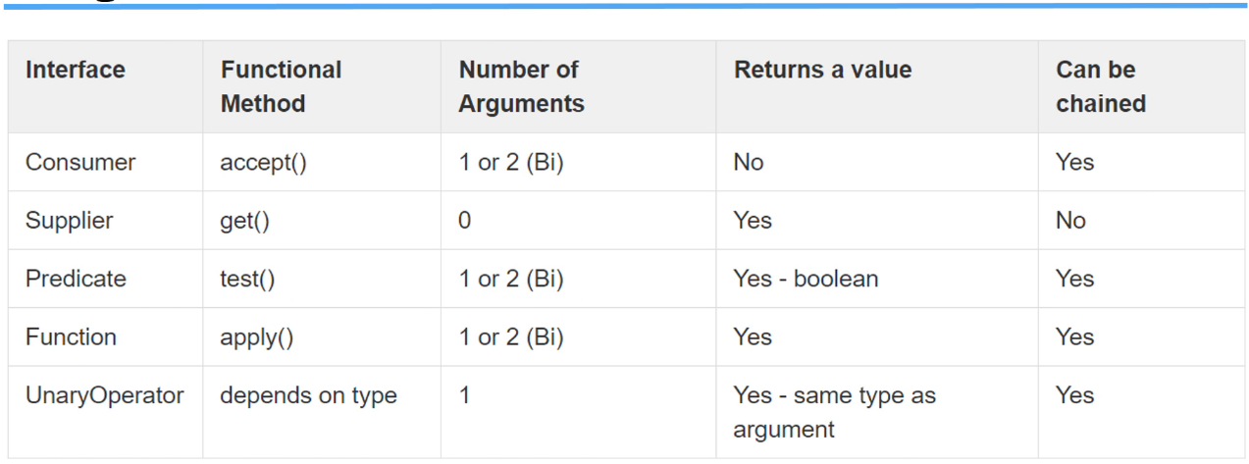

* Consumers don’t return a value so how does the andThen() work for them? Rather than working on the result of the previous Consumer, each Consumer in the chain runs using the argument as passed to the accept() method.  
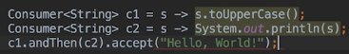 Hello, World!  
=> Remember that the Consumers don’t return anything so the result of the toUpperCase() call in Consumer c1 is actually lost. Each Consumer in the chain is evaluated independently of the others so there’s no real advantage in this case to chain them together but it can be done.

**Streams**  
* When you think of a stream, you might be thinking of IO Streams like InputStream and OutputStream but those aren’t the type of streams that we’re gonna be covering here.  
* Streams in this context are completely unrelated to IO.  
* In this video when we refer to streams, we mean the **sequence of computations**.  
* Another way of putting it is **a set of computational steps that are chained together**.  
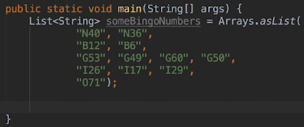  
* Arrays.asList() converts it to a list of string objects, creates and populates the list.  
* Let’s say we want to print out the numbers in column G.   
* We could use a for loop of course but let’s use a forEach() with Consumer.  
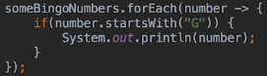  
* **String startsWith()**  
* If we wanted a lower case `g` too:  
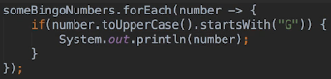  
* Let’s now sort the strings before printing them.  
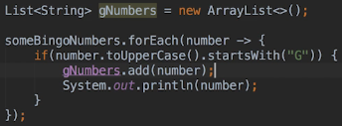  
* IntelliJ isn’t complaining but remember the scoping rules when using lambdas - the scope of this lambda is within the scope of the main() method’s body, so we can use variabled declared in main() in lambda expressions inside main() as long as those variables are effectively final.   
* In this case we’re changing the contents of our gNumbers list but the object reference stored in the gNumbers variable doesn’t change and so gNumbers is effectively final and therefore we can use it within the lambda.

  
* We could’ve used an anonymous class instead of a lambda and a for loop instead of a forEach().  
* We don’t need to specify the parameter types in any of the lambdas but I sometimes like to see them there for readability.  
* We’re now using 4 statements to do all this, we can actually use just 1 statement:  
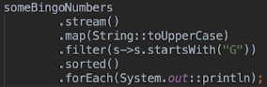  
* **Stream** => a sequence of elements supporting sequential and parallel aggregate operations.  
* **stream()** => In practice a Stream is a set of object references. The stream method which was added to the Collections class in Java 8, creates a stream from a Collection. Each object reference in the stream corresponds to an object in the Collection and the ordering of the object reference matches the ordering of the Collection. The stream() will always be the first call we make.  
* Any stream operations that we use have to meet 2 requirements first:  
1) **They must be non-interfering which means that they don’t change the stream source in any way**.  
2) **They must be stateless, so the result of an operation can’t depend on any state outside of the operation**.  
* Example of the 2) would be that it can’t depend on variable values in a previous step. So each operation should be seen as an independent step that’s operating on a stream argument.  
*  **::**  => **method reference**, we can use them when all a lambda does is call an existing method. We could’ve been using them all along but I figured it was a good place to introduce them here.  
* **map()** => accepts a Function. A Function accepts 1 argument and returns a value.  
* In this case, we’re mapping a String.toUpperCase() method to Function so the method itself doesn’t accept the parameter but there is a source string and it’s the string object we’re using to invoke the method. So that’s mapped to the argument Function and the return value is a string returned from toUpperCase().  
* Something like this:  
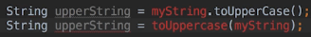  
* And because the String.toUpperCase() method can be mapped to function in this way, we can then pass it to the map() method as a method reference.  
* This would be valid as well:  
  
* So to use a method reference for a method that takes parameters, the compiler has to be able to infer what the arguments are.  
* We can’t use method reference for the startsWith() method because there’s no way for the compiler to know that the argument should be `G`.

**Streams - Intermediate and Terminal Operations**  
* We wouldn’t be able to do that with a method that expects 2 arguments because that method can’t be mapped to a Function. The map() method wants a Function, not a BiFunction. We can pass a lambda that matches the Function pattern - accepts 1 argument, returns 1 value. In this case there just happens to be a method in the String class that does what we want to do. Obviously the method we use has to work with the item types in the stream.  
* It’s called map() because it’s essentially mapping each item in the input stream to the result returned by the function argument. The resulting stream will have the same number of items as the source stream.

* Remember when we chained together Functions and a Function in the chain would operate on the result from the last Function in the chain? Essentially this is what’s happening here. Each stream operation operates on the stream result from the last step.  
* **filter()** => **wants a Predicate, not a Function**.  
* **sorted()** => sorts based on the natural ordering of the items in the stream. **There’s also a version of the sorted() method that accepts a Comparator parameter**.  
* The forEach() we’re using here is not the same one we used with the Iterable interface.  
=> In this case we’re using the forEach() method from the stream class.  
* **In fact all the steps have used methods from the Stream class which makes sense because the object type returned from the stream() method is a Stream and therefore from that point forward every method we call operates on a Stream namyle the Stream returned from the previous step**.  
* The Stream forEach() does what the Iterator one does - it accepts a Consumer as a parameter and evaluate the Consumer for each item in the stream.  
* **Since the System.out.println() method accepts an argument and doesn’t return a value, we can map that to Consumer**. And we’re passing it to the forEach() method using a method reference.  
* In the past, we could’ve used:  
  
* But we needed to learn how Lambda Expressions map to the interfaces in the java.util.function package before we started to use shortcuts, which is why we did this instead:  
  
* The forEach() method doesn’t return anything so the chain has to end here.  
=> Because of that, the forEach() method is called a **Terminal** **Operation**.  
* A Terminal Operation returns either void or non-stream result. Since every operation in a chain requires a source stream, ultimately the chain has to end when we use a Terminal Operation.  
* Operations that return a Stream are called **Intermediate** **Operations** because they don’t force the end of the chain.  
* **Stream Pipeline**.  
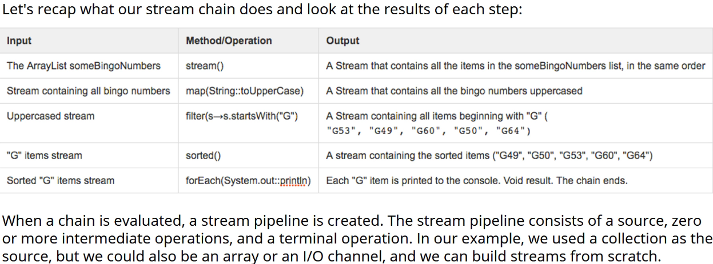

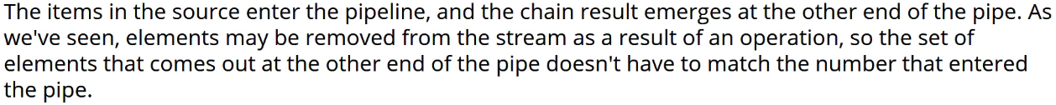

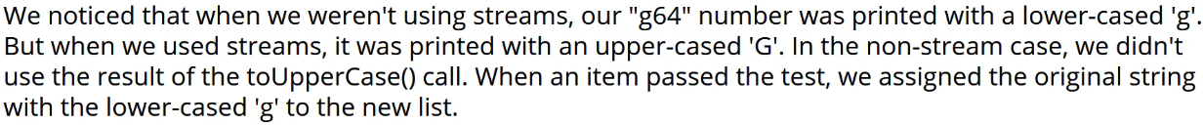

  
* Let’s look at what else we can actually do with Streams.  
* **Rather than creating a stream based on a Collection, we can create one from scratch**.  
* **Stream.of()**\* **Stream.concat()**\* **Stream** **count()**  
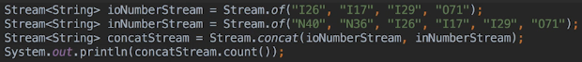  
* We could do it by changing the stream chain but I want to show you how to use the of() method.  
* That gives us a Stream of String objects. We **can create Streams composed of any type of object** but **we can’t create a stream of mixed types**.  
* The concat() method is static so we can’t use it in the chain but we can use the result as the source for a chain.  
* Since count() returns a long value, it’s a Terminal Operation.  
* Right now our stream contains duplicate numbers but we can remove them using the distinct() method which uses the equals() method to determine which objects are duplicates.  
* **Stream distinct()**  
  
* Can we print out the items in a stream but without ending the chain?  
=> Let’s say we’re trying to debug a long chain and we wanted to print the results of each operation in the chain.  
* We know we can use the forEach() method but that’s actually a Terminal Operation.  
=> Instead, we could use the **peek()** method which accepts a Consumer argument. It evaluates the Consumer for each item in the source stream and then adds the item to a new stream which it then returns.  
=> Now since it returns a stream value, it’s an Intermediate Operation, the chain doesn’t have to end.  
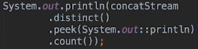  
* **The peek() method mainly exists to support debugging**.

**Streams - Flatmap & Lambda Best Practices**  
* **map()** => can transform 1 objects. It takes a Function as an argument which takes 1 object and returns a value.  
* **flatMap()** => we may want to map a single object to more than one object and we can use a flapMap() method to achieve that. It takes a Function as an argument which returns a Stream value. So we can pass an object as the Function argument and return a string containing several objects which means that we’re effectively mapping 1 object to many. In fact, that’s the intended use of the flapMap() method.  
* Let’s add a toString() method to our Employee class:  
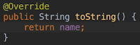  
  
  
  
* Let’s create a Department class:  
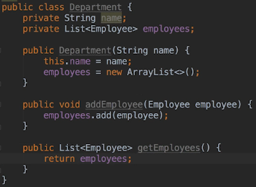  
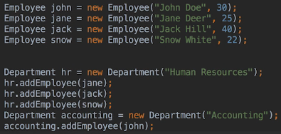  
* Let’s suppose we want to print all the employees that work for the company.  
* Now of course we could add a printEmployees method to the Department class and then iterate over this list and print the employees but let’s use streams and have a look at how the flapMap() method might help us do that instead.  
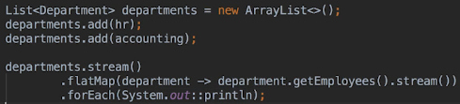  
* You can see that the flapMap() wants a function that returns a stream. Each department in the source stream becomes the argument to the function. For each department we call the getEmployees() method which returns a list and then we call the stream() method on that list to return a stream of employees. The items in this stream were added to the stream that will be returned from the flapMap() method. In the case of an HR department, we have gone from 1 department object to 3 employee objects.  
* **The method is called flapMap() because it’s often used to flatten nested lists**. In this case there are lists of employees nested within the department list so the flapMap() method is the one to use when we want to perform operations on the list but the list isn’t the source. We use the method to create a stream of all the objects in those lists.  
* **collect()** => another handy method, this is a Terminal Operation. It collects the elements in a stream into a different type of result.  
* For example we can add all the items in the stream to list or set. After all unless the purpose of the chain is to produce a list of items to print, we’re going to usually want to save the result somewhere.  
* You might be using streams to selectively reduce and sort a large list because you may want to use the reduced list in subsequent code. So I would use the collect() method to create the reduced list.

* **Collectors.toList()**  
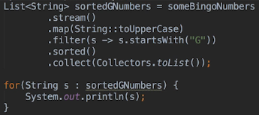  
* Now we have a list that we can continue to work with if we wanted to.  
* **There are 2 versions of the collect() method**.  
1) accepts a Collector which is an interface to the java.util.stream package. Underneath the covers, this version of the method maps the Collector to the arguments required by the second version of the method  
2) expects 3 arguments: a **Supplier**, a **BiConsumerAccumulator** and **BiConsumerCombiner**. These arguments let us be specific about how we want the items to be added to the result of collect().  
* Let’s say we want to end up with an ArrayList rather than a List. We can use the more specific collect() version of the method to do this.  
  
* Arguments:  
=> 1) **Supplier** => **creates objects**. We want an ArrayList so we passed the ArrayList::new which will construct a new ArrayList for us. **When passing Method References, we use the ::new when we want to pass the constructor**.  
=> 2) **Accumulator** => add() method, that’s how it will add the items to the ArrayList. The Accumulator is used when the Runtime needs to add a single item into the list - into the result.  
=> 3) **Combiner** => is sometimes used to improve the efficiency of the operation. If and when to do this is really up to the Java Runtime.   
* There are many APIs that we can map to the Supplier, Accumulator and Combiner and this allows us to do all sorts of things using collect().  
* For example if we have a lot of employees and there are groups of employees with the same age, we can create a map of lists based on age using the   
**Collectors.groupingBy()** method.  
* It would look like this:  
  
* The last method we’re gonna look at is the reduce() method.  
* **reduce()** => combines all the items in the stream into a single result.  
* There are 3 versions of this object. We’re gonna use the simplest one which reduces a stream to 1 of the elements in the stream. For example if you wanted to use a stream to find the youngest employee in the company.  
* **ifPresent()** => we use this because this form of reduce() has an optional result.  
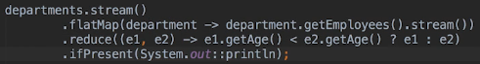  
* This version of the reduce() accepts a BiFunction which expects 2 arguments and returns a result. This compares the ages of 2 employees and returns the younger employee. So the result of the reduce() method will be the youngest employee in the stream.  
* The reduce() method is a Terminal Operation. So the isPresent() isn’t part of the stream operation chain as such. Here we’re just chaining a non-stream method call on to the stream chain result.  
* **A few notes about streams**:  
=> We can’t reuse them. Once we’ve called a Terminal Operation on a stream, we’ll receive the IllegalStateException if we try to operate on that stream again.  
=> Operations in streams are lazily evaluated, that means that the Intermediate Operations are not performed until there’s a Terminal Operation.  
=> We can use a more specific Stream interfaces when we’re working with lists of numbers, so IntStream, LongStream, DoubleStream for example. These interfaces have additional methods like sum() min() max() and a few others that are useful when working with numbers.  
=> There’s also **Parallel** **Streams** which we use when we want to increase performance by executing streams in parallel. Whether you need to do that would really depend on your application. Parallel Streams are outside the scope of this section. I just really want to point out that we can get a Parallel Stream from a Collection by using the **parallelStream()** method.  
* Let’s look ata the lazy evaluation.  
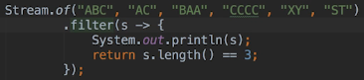  
* **The filter() method accepts a Predicate which takes 1 argument and returns true/false. There’s nothing stopping us from doing other things inside the Predicate**.  
* If the last thing in the chain was the filter() method, nothing would be printed because stream operations are lazily evaluated, in other words nothing happens until there’s a Terminal Operation.  
* This makes sense though - if we have a long chain of Intermediate Operations but no Terminal Operation, then there’s nothing coming at the bottom of the pipe so it would be a waste of time to execute all the Intermediate Operations.  
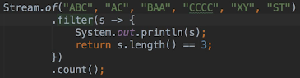  
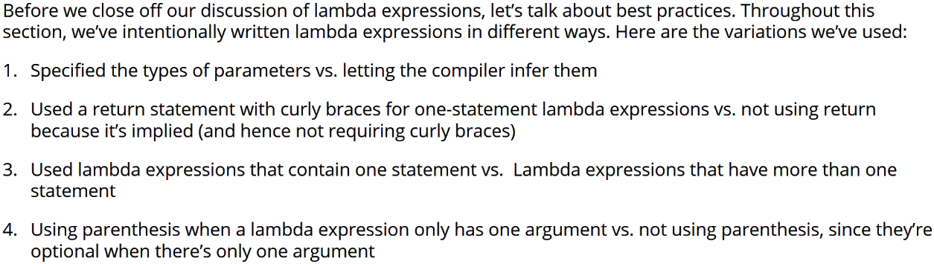  


* **Best Practices**  
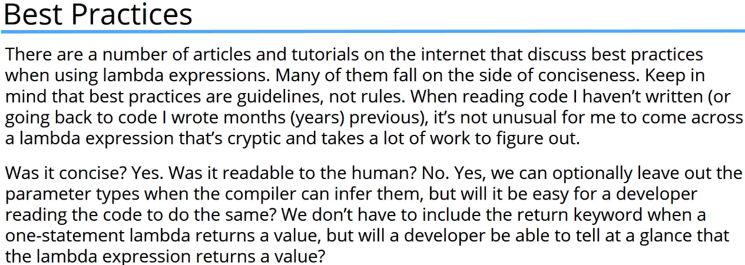

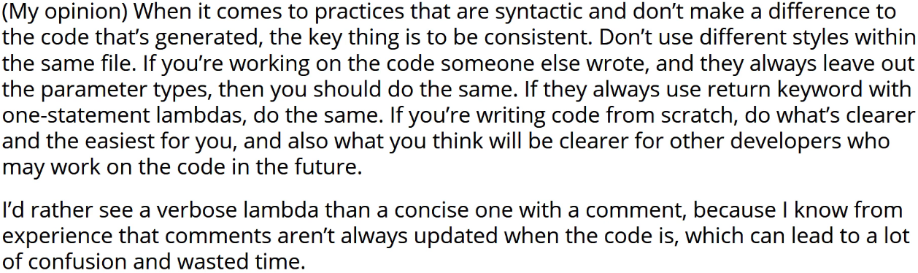

**Lambda Challenge Part 1**  
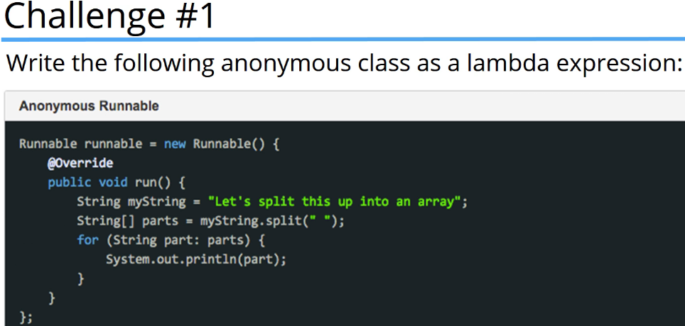  
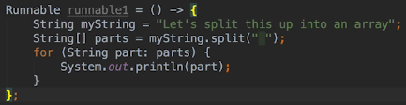  
* Does this Lambda map to any of the interfaces in the java.util.function package? No it doesnt, it doesn’t take any arguments and it doesn’t return any value. All the interfaces in java.util.function package either take an argument or arguements or return a value or do both.  
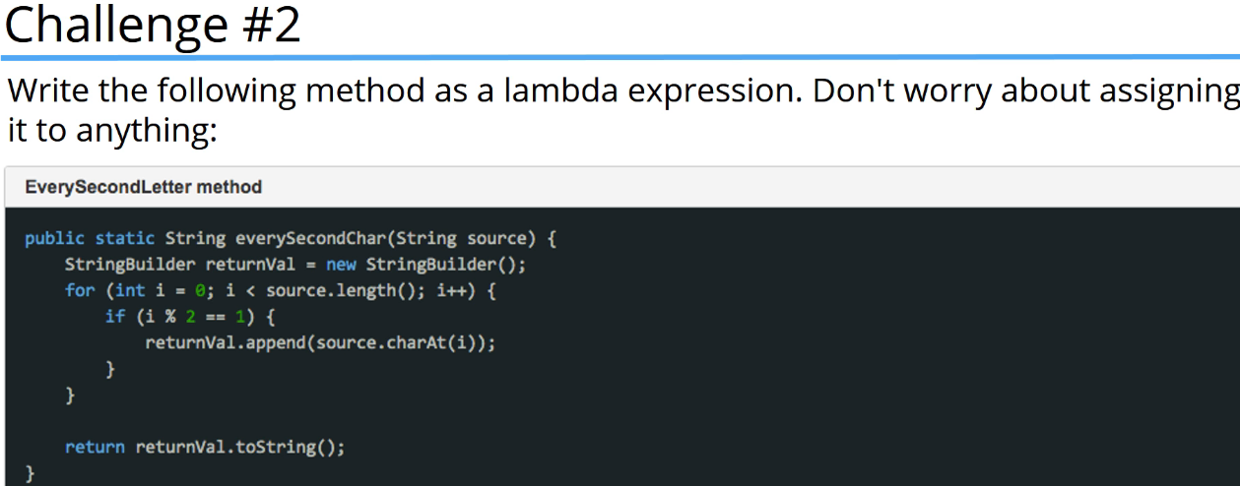  
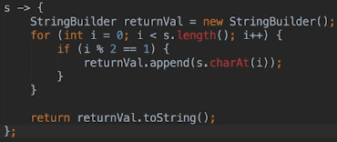  
* We could’ve used the type => (String s) ->  
* In this case this Lambda takes 1 parameter and returns a value so it maps to   
Function<String, String>  
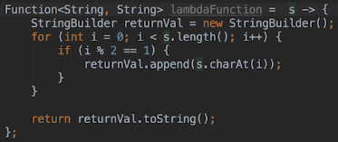  
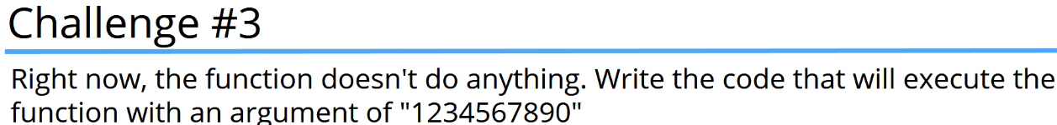  
  
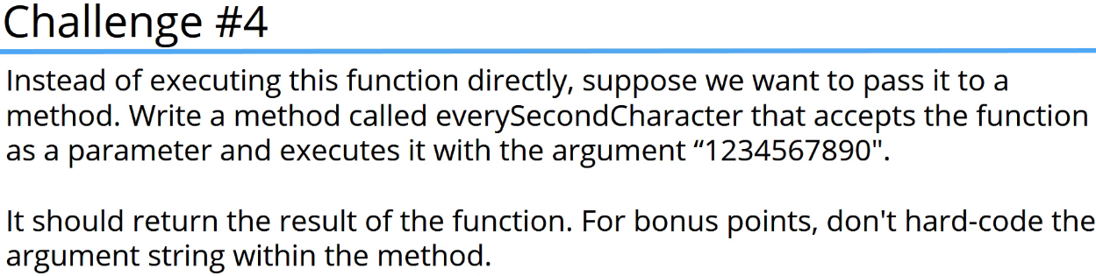  


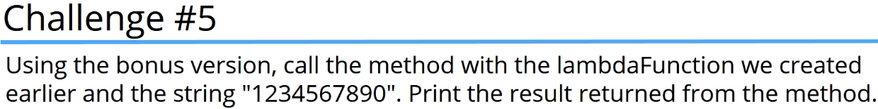   
  
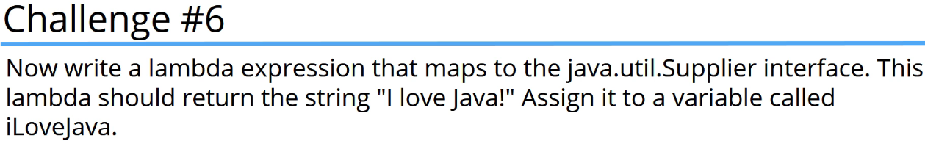  
* Supplier produces objects. It doesn’t actually accept any arguments and since the lambda body here is a single statement, we don’t have to include the return keyword because it’s implied.  
  
  
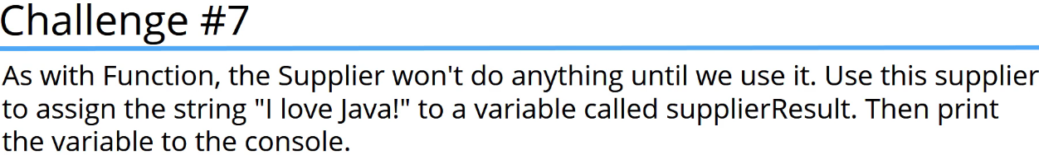  
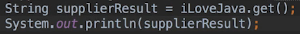

**Lambda Challenge Part 2**  
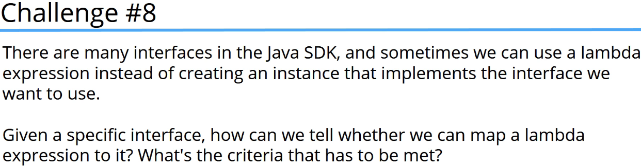

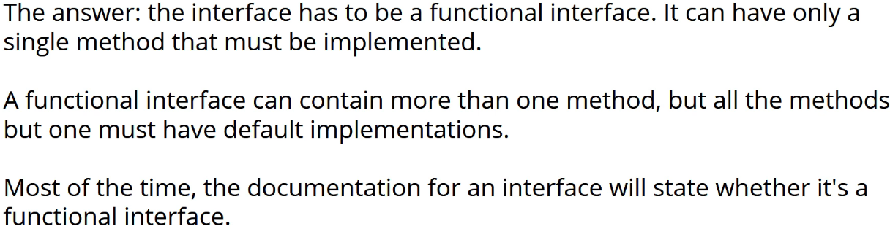

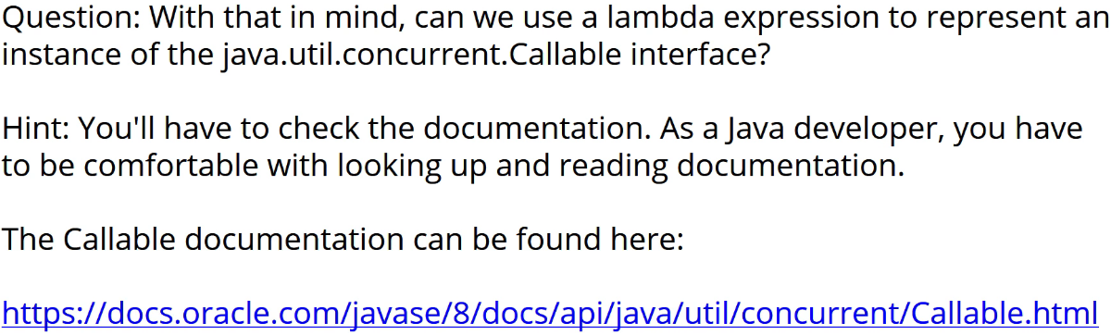

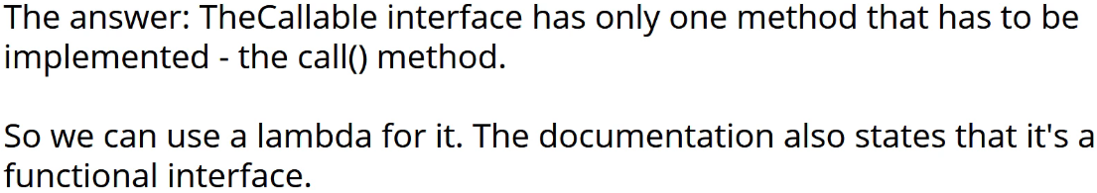

  
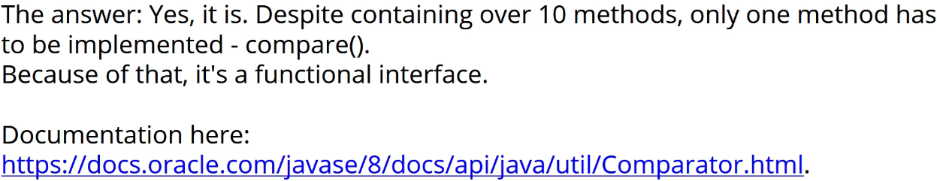  
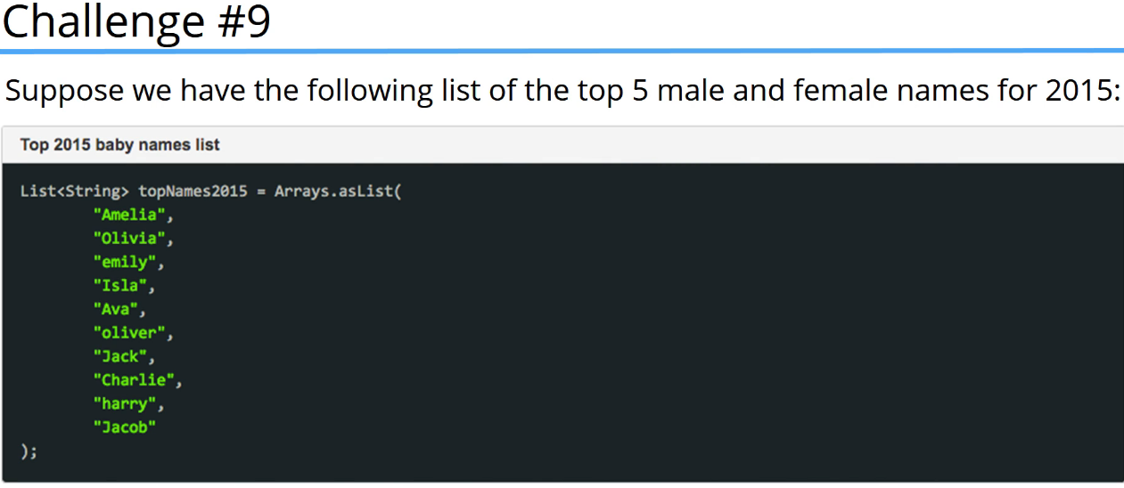  
  
* There were many ways to complete this.  
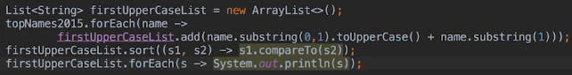  
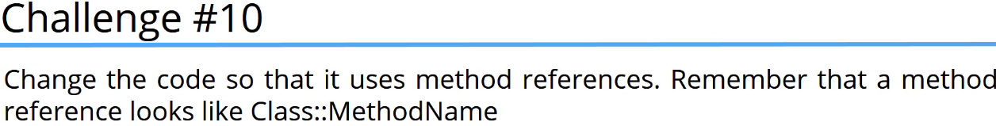  
* **Class::MethodName**  
  
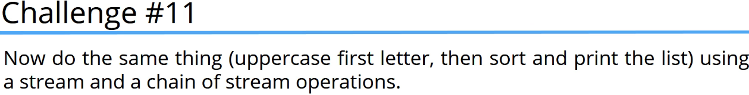  
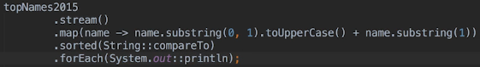  
* A couple of things to note here:  
=> We didn’t have to create a new list to hold the names with uppercased first letters. The map() method returns a stream containing all the transformed names.  
=> This code is a little more concise than the previous versions and just as easy to read in this case.  
* We want from Java code that used lambda expressions to more concise code that used method references to streams. This is a good way of doing it when you’re learning how to do it - you start by using the more verbose version that doesn’t use lambdas but uses anonymous classes, you can then replace the anynomous classes with lambdas or use method references when applicable. And then finally we can rewrite the code to use streams but of course only when it makes sense to use them.  


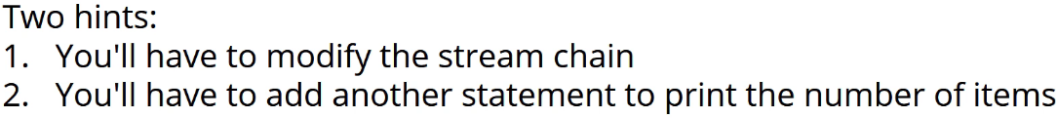  
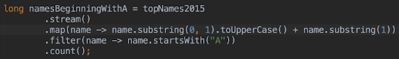  
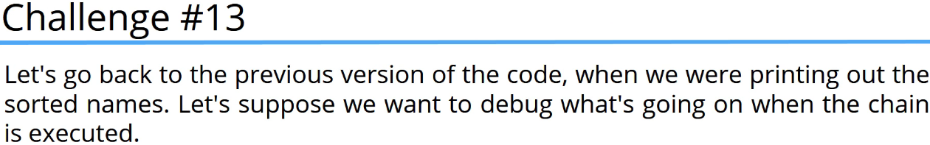

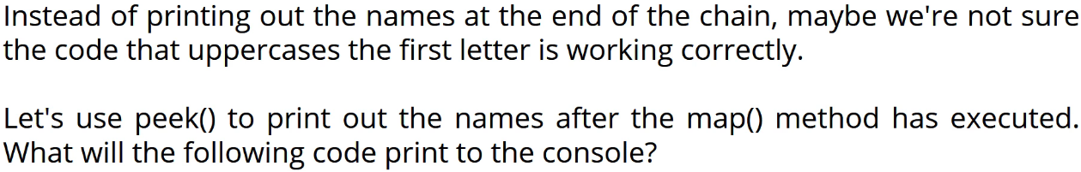

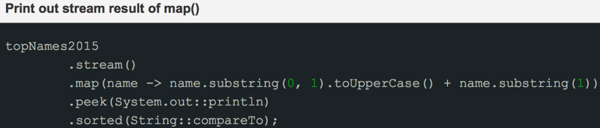  
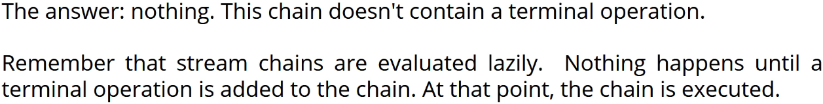

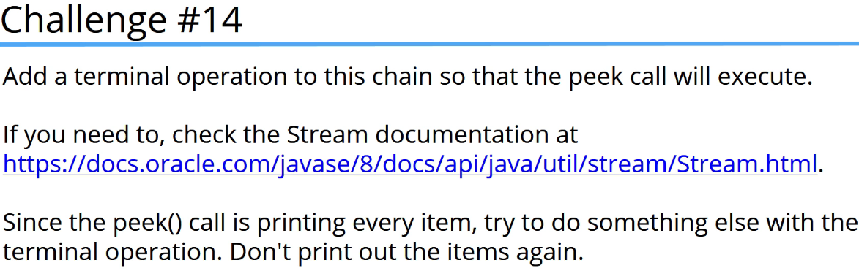  
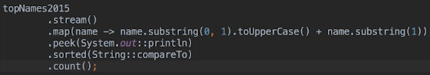  
* Even though we’re throwing away the result, the code run and prints out the names which aren’t sorted yet.  
* We don’t have to use the result of the Terminal Operations.

* Instead of count() we could also use collect():  
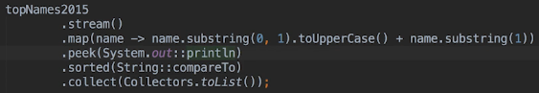  
* We used it to store the result of a chain into a list. We may want to pass the result to a method or do something else with the list at that point.

* **My advice is to get used to working with Lambdas and Streams by practicing using them. At some point you’ll think of a Lambda Expression first rather than using an Anonymous Class**.  
* Lambdas are really quite interesting and useful.

**Resources**  
Interface Comparator<T>  
<https://docs.oracle.com/javase/8/docs/api/java/util/Comparator.html>  
Functional Programming  
<https://en.wikipedia.org/wiki/Functional_programming>  
Interface Consumer<T>  
<https://docs.oracle.com/javase/8/docs/api/java/util/function/Consumer.html>   
Package java.util.function  
<https://docs.oracle.com/javase/8/docs/api/java/util/function/package-summary.html>   
Method References  
<https://docs.oracle.com/javase/tutorial/java/javaOO/methodreferences.html>   
Interface Stream  
<https://docs.oracle.com/javase/8/docs/api/java/util/stream/Stream.html>   
Interface Callable  
<https://docs.oracle.com/javase/7/docs/api/java/util/concurrent/Callable.html>